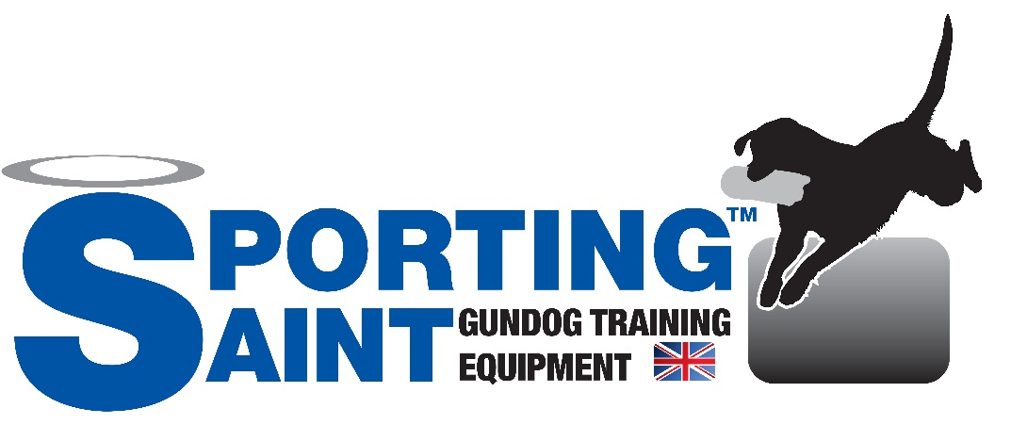

social media brand ambassador/assoicate form

Sporting Saint are looking for an active and passionate Social Media Ambassador/Associate to join our current team to help promote, test and provide feedback about the Sporting Saint brand.
Our social media associates can expect a number of benefits such as but limited to;
- An agreed amount of free items over the year to test, provide feedback, personal use or review for your followers
- Exposure across our social media platforms
- Exposure on our newly designed website & Associate page
- Being part of the Sporting Saint community
Plus more to be agreed with the applicant at time of contact.
If interested, please fill out the form below and return it to submissions@sportingsaint.co.uk – any information provided is protected and will NOT be used for any sales or marketing related newsletters. Your information is NEVER passed onto third parties.

Personal infomration
Full Name__________________________________________ Are you over 18 years old?____________
Address_______________________________________________________________________________
______________________________________________________________________________________
Country____________________________________________Postcode___________________________
Phone Number_________________________________________________________________________
Email Address__________________________________________________________________________
Are you a Trainer?________________________ Do you breed your Dogs?_________________________
Are you a current customer of Sporting Saint?_________ Average Order Value?___________________

DOG INFORMATION
How many Dog(s) do you own?____________________________________________________________
What Breed are they? ___________________________________________________________________
______________________________________________________________________________________
How old are is/your Dog(s)?___________ Male or Female?___________ Do they compete?_________
Have you trained them yourself or professionally? Or Both?___________________________________
If professionally, who trained them?_______________________________________________________
Favourite training equipment?____________________________________________________________

Social MEdia Information
Are you on Facebook? ________ Are you on Instagram?_______ Are you on Twitter?_______________
Facebook Followers? _________ Instagram Followers?_________ Twitter Followers?_______________
Of the above which platform would you class as your “main” platform? ________________________
What is the majority of your content made up of? I.E. Training Photos/Updates, Life updates, Product reviews… ______________________________________________________________________________________
______________________________________________________________________________________
______________________________________________________________________________________
On a scale of 1 to 10 how interactive are you with your followers? 1 being no interaction & 10 being answers/likes every comment/message? _______
Please write down your social media handles
______________________________________________________________________________________
______________________________________________________________________________________

Questions about Sporting Saint
Do you currently feature Sporting Saint products on your Social media?_________________________
Is there any Sporting Saint product you’ve wanted to test/review but never bought?_______________________________________________________________________________
Do you have any suggestion as to what Sporting Saint could improve?
______________________________________________________________________________________
______________________________________________________________________________________
______________________________________________________________________________________
______________________________________________________________________________________
Is there any product you think we should be making/stocking/selling that we don’t currently?
______________________________________________________________________________________
______________________________________________________________________________________

Signature & Disclaimer
I certify that I am above the age of 18 years old and Sporting Saint Limited may contact me in regards to the position in this form.
If this application is accepted, I understand that false or misleading information in my application may lead to immediate suspension of any relationship between both parties. More T&C’s to follow if application is accepted.

SIGNATURE______________________________________________DATE__________________________
PRINTED NAMED________________________________________________________________________

